Project Design Phase-II

Data Flow Diagram & User Stories
Date | 19 September 2026
Team ID | Shaik Irshad - 238W1A4256
Project Name | Automated Network Request Management In ServiceNow
Maximum Marks | 4 Marks

Data Flow Diagrams
A Data Flow Diagram (DFD) shows how data enters and leaves the system, what transforms it, and where it is stored. The two diagrams below describe the actual Network Request implementation: a context-level (Level-0) view of the system's external interactions, followed by a Level-1 view of the internal processes and the backend data store.
Level-0 — Context Diagram
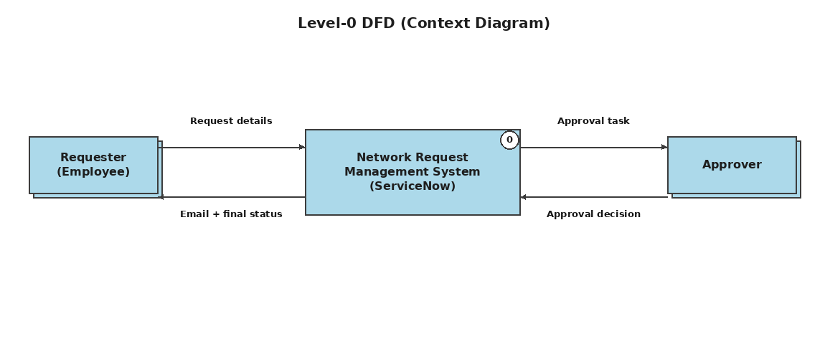
Level-1 — Detailed Process View
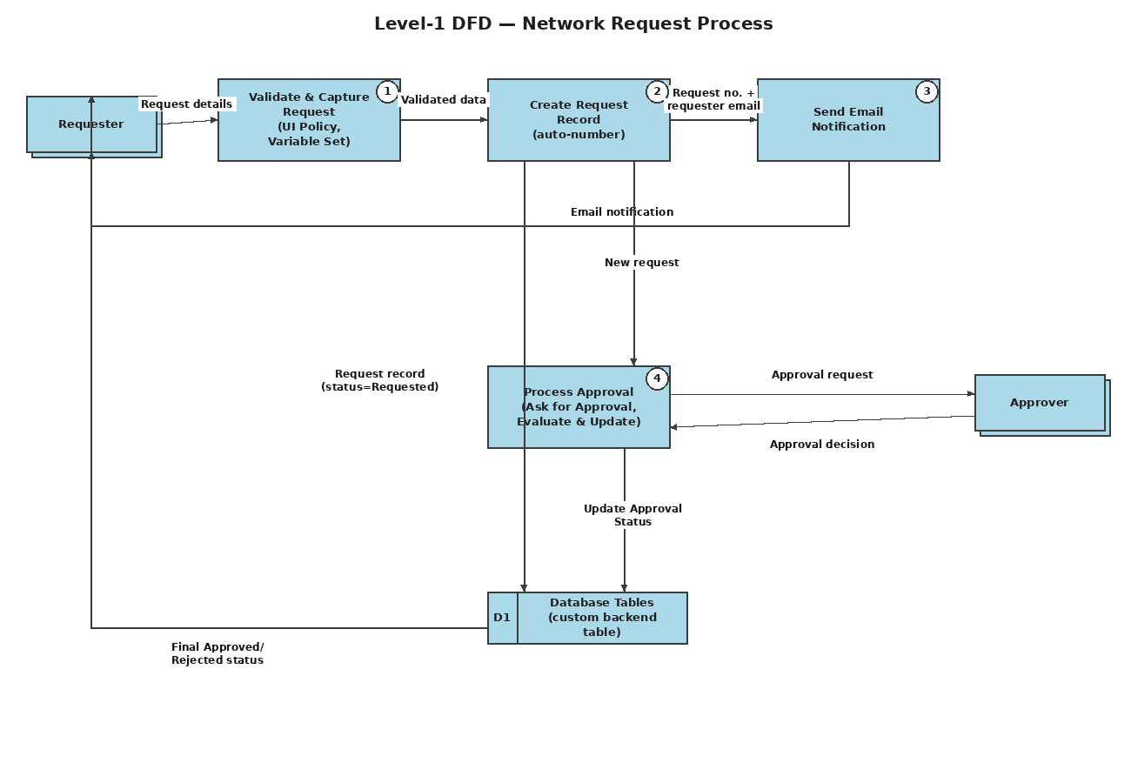

User Stories
The table below lists the user stories for the Network Request solution across its three actors — the Requester, the Approver, and the ServiceNow Admin — grouped by the functional epics defined in the Solution Requirements document.
User Type | Functional Requirement (Epic) | User Story Number | User Story / Task | Acceptance Criteria | Priority | Release
Requester (Employee) | Network Request Submission | USN-1 | As a requester, I can open the Network Request catalog item from the Service Portal and enter my request details. | The Network Request form loads with all fields (Requested For, Mobile Number, Type of Connection, Total Amount, Mode of Payment, Address). | High | Sprint-1
Requester (Employee) | Network Request Submission | USN-2 | As a requester, I cannot submit the request if a mandatory field is left blank. | Submission is blocked and a validation message appears if Mobile Number, Type of Connection, Total Amount, Mode of Payment or Address is empty. | High | Sprint-1
Requester (Employee) | Network Request Submission | USN-3 | As a requester, I can select whether my connection is New or Existing. | Choosing New or Existing correctly stores the value in the Type of Connection field. | High | Sprint-1
Requester (Employee) | Dynamic Form Behaviour | USN-4 | As a requester, I only see the “Enter your Existing ID” field when I select Existing connection. | The Existing ID field is hidden for New and visible for Existing, controlled by the Catalog UI Policy. | Medium | Sprint-1
Requester (Employee) | Requester Info Auto-Population | USN-5 | As a requester, my email, name and phone number are filled in automatically once I set “Opened on behalf of”. | Email ID, User Name and Phone Number populate without manual typing, using the User Information variable set. | Medium | Sprint-1
Requester (Employee) | Email Notification | USN-6 | As a requester, I receive an email once my request has been created in the backend. | An email with a greeting, request details and the generated request number arrives in my inbox after submission. | High | Sprint-2
Requester (Employee) | Status Tracking & Traceability | USN-7 | As a requester, I can check whether my request is still pending or has been Approved/Rejected. | The Database Tables record's Approval Status field and related approval list reflect the current state at any time. | High | Sprint-2
Approver | Approval Workflow | USN-8 | As an approver, I receive an approval request when a new Network Request is submitted. | A sysapproval_approver record is created and assigned to me as soon as the backend record is created. | High | Sprint-2
Approver | Approval Workflow | USN-9 | As an approver, I can approve or reject a network request. | Selecting Approve or Reject on the approval record is captured by the flow's approval outcome. | High | Sprint-2
Approver | Approval Workflow | USN-10 | As an approver, my decision automatically updates the request's final status. | Approving sets Approval Status = Approved; rejecting sets Approval Status = Rejected on the Database Tables record. | High | Sprint-2
ServiceNow Admin | Backend Configuration | USN-11 | As an admin, I can see all submitted network requests as structured records in one custom table. | Every submission creates one row in the Database Tables table with a unique auto-generated Database Number. | Medium | Sprint-1
ServiceNow Admin | Backend Configuration | USN-12 | As an admin, I can trace an approval back to the request record it belongs to. | The Approval Request relationship and related list on the Database Tables form show the linked sysapproval_approver record(s). | Medium | Sprint-2
ServiceNow Admin | Security & Access | USN-13 | As an admin, I want the new table to be secured without building a custom access framework. | The default ACLs auto-generated by ServiceNow for the new table govern read/write access to Network Request records. | Low | Sprint-2
ServiceNow Admin | Troubleshooting | USN-14 | As an admin, I can diagnose why a submission did not trigger the expected automation. | Flow Execution Details, email logs and backend record checks are available to trace each step of a request. | Medium | Sprint-2

